Iligan Buy & Sell

VISION

* A buying and selling system that allows people of IliganCity to buy and sell products online.

MISSION

* To create an efficient software for buying and selling products.

OVERVIEW

* Buy and sell database tends to give opportunity to the USER, enable them to sell their item(s) that are no longer needed, as well as it gives opportunity to buy product(s) posted by their co-users. In this set-up, there are items grouped according to the category they belong. Items can be directly access through their designated ID. For instance, the user can send as many messages he/she wants enable for him/her to communicate with the other users.

SCOPE AND LIMITATIONS

* This database is limited to Iliganons and only to those that are capable to register plus to those who are willing to buy and sell products online.

DATA REQUIREMENTS

A database needs to be developed that buy and sell products.

* A registered user can post many items. User composed of ID, email, last name, first name, and contact number. And also, a feature that can determine whether the user is active, admin or staff.
* A user can also add comments to any of the posted item.
* An item consist of ID, name, category ID, price, description, type ID, user ID, and the date it was posted. Each item accepts several comments by different users. To make the items more appealing to the buyers, it displays image of that certain product.
* An image cle, contains ID, title, creation date, stuff image and item ID.
* An item is classified according to its category, where category needs ID and name.
* An item is also grouped according to its type (buy/sell), where type generates name and ID.
* Another feature is added and it is called “Ranking”, it contains an id and name, it ranks the item based on updated comments.

Features

* Post “BUY” item
* Post “SELL” item
* Comment to post
* Edit post
* Edit profile
* Display all items according to category
* Display all items according to its type
* Active post

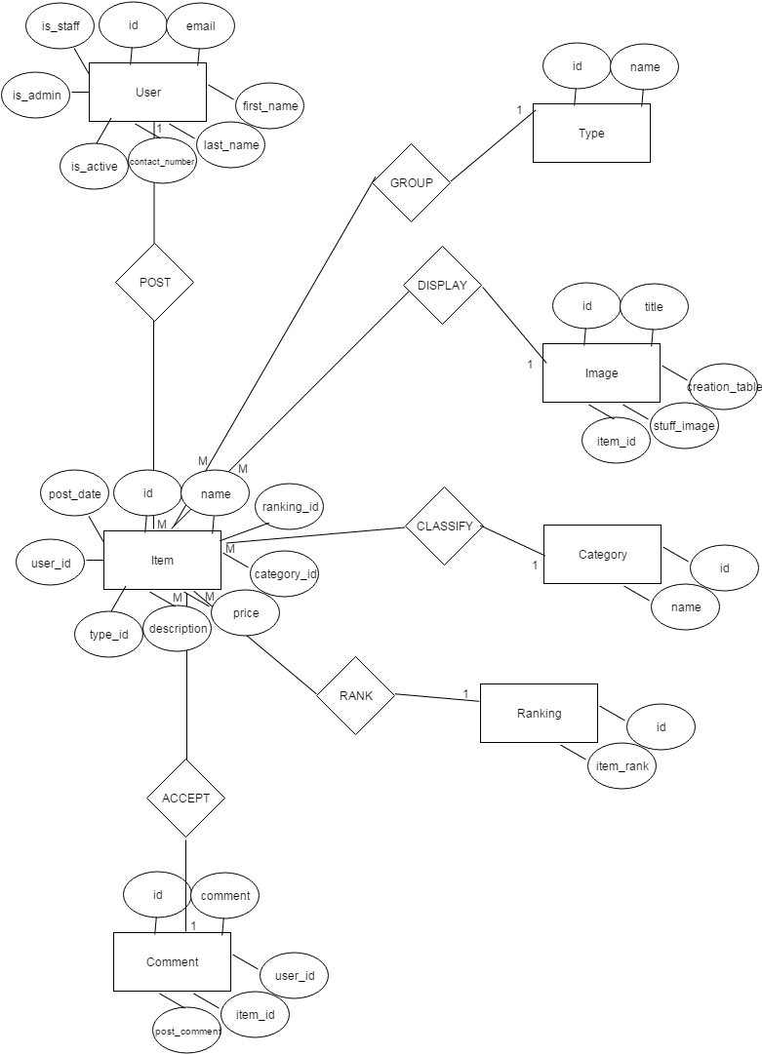 ERD MODEL

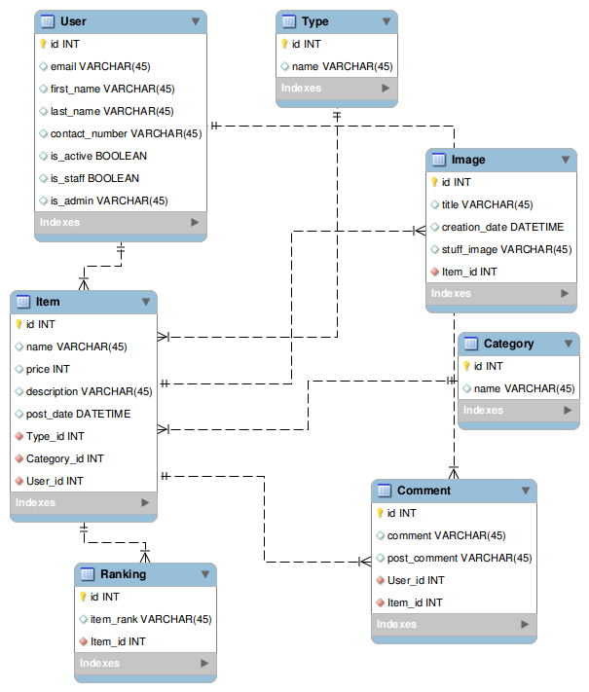RELATIONAL SCHEMA